Exit Pass
Name:
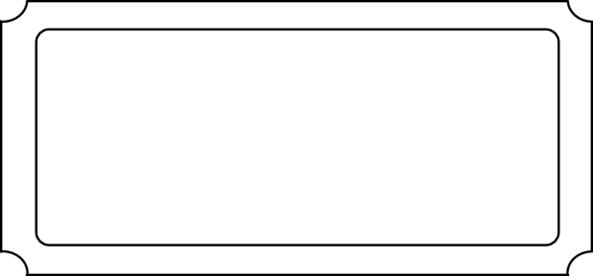
Give an example of a combined event ________________________________
Draw a two way table which shows two dice being thrown ?
+
What is the probability of throwing a 7 ? _____________

What is the probability of throwing a 12? _____________

Exit Pass
Name:

Give an example of a combined event ________________________________
Draw a two way table which shows two dice being thrown ?
+
What is the probability of throwing a 7 ? _____________

What is the probability of throwing a 12? _____________

